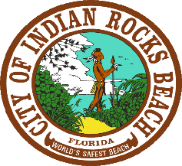

CITY OF INDIAN ROCKS BEACH
TEMPORARY INTERSECTION CLOSURE

The Intersection of Janice Place and Barry Place will be Temporarily Closed due to construction activities from January 3, 2023, until January 16, 2023.
The City appreciates your patience and understanding during this time frame.
For questions, please contact the Public Works Department – 727-595-6889
WORKING TOGETHER

